WEEK 1 HANDS_ON
PL/SQL EXERCISES
Exercise 1: Control Structures
Step 1: Create the Tables
CREATE TABLE Customers (
CustomerID NUMBER PRIMARY KEY,
Name VARCHAR2(50),
Age NUMBER,
Balance NUMBER(10,2),
IsVIP CHAR(1),
LoanInterestRate NUMBER(5,2)
);

CREATE TABLE Loans (
LoanID NUMBER PRIMARY KEY,
CustomerID NUMBER REFERENCES Customers(CustomerID),
DueDate DATE,
Amount NUMBER(10,2)
);
Step 2: Insert Sample Data
INSERT INTO Customers VALUES (1, 'Ravi', 65, 12000, 'N', 5.5);
INSERT INTO Customers VALUES (2, 'Meena', 45, 8000, 'N', 6.0);
INSERT INTO Customers VALUES (3, 'Arun', 70, 15000, 'N', 7.0);

INSERT INTO Loans VALUES (101, 1, SYSDATE + 20, 50000);
INSERT INTO Loans VALUES (102, 2, SYSDATE + 40, 30000);
INSERT INTO Loans VALUES (103, 3, SYSDATE + 10, 45000);

COMMIT;
Step 3: Verify Tables
SELECT * FROM Customers;
SELECT * FROM Loans;
Step 4:Executing Scenarios
-- Enable output
SET SERVEROUTPUT ON;

-- Scenario 1: Discount loan interest rate for customers over 60
BEGIN
FOR rec IN (SELECT CustomerID, Age, LoanInterestRate FROM Customers) LOOP
IF rec.Age > 60 THEN
UPDATE Customers
SET LoanInterestRate = LoanInterestRate - 0.01
WHERE CustomerID = rec.CustomerID;
DBMS_OUTPUT.PUT_LINE('Discount applied for CustomerID: ' || rec.CustomerID);
END IF;
END LOOP;
COMMIT;
END;
/

-- Scenario 2: Promote customers with balance > 10,000 to VIP
BEGIN
FOR rec IN (SELECT CustomerID, Balance, IsVIP FROM Customers) LOOP
IF rec.Balance > 10000 AND rec.IsVIP = 'N' THEN
UPDATE Customers
SET IsVIP = 'Y'
WHERE CustomerID = rec.CustomerID;
DBMS_OUTPUT.PUT_LINE('CustomerID ' || rec.CustomerID || ' promoted to VIP');
END IF;
END LOOP;
COMMIT;
END;
/

-- Scenario 3: Send reminders for loans due within 30 days
BEGIN
FOR rec IN (SELECT LoanID, CustomerID, DueDate FROM Loans WHERE DueDate <= SYSDATE + 30) LOOP
DBMS_OUTPUT.PUT_LINE('Reminder: LoanID ' || rec.LoanID ||
' for CustomerID ' || rec.CustomerID ||
' is due on ' || TO_CHAR(rec.DueDate, 'DD-MON-YYYY'));
END LOOP;
END;
/
OUTPUT:
SCENARIO 1
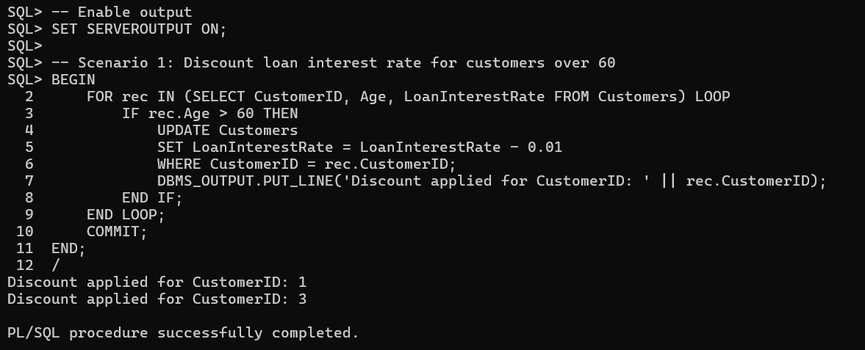
SCENARIO 2: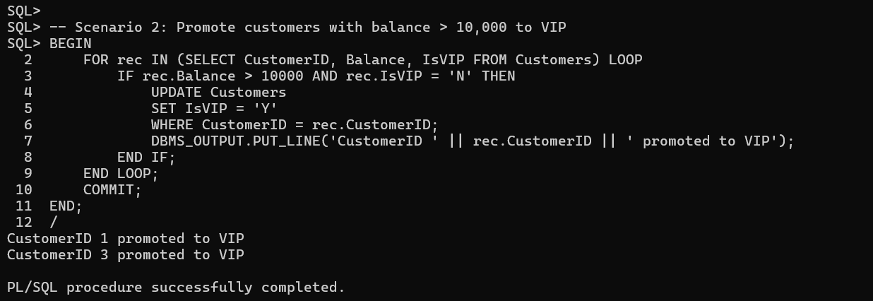
SCENARIO 3: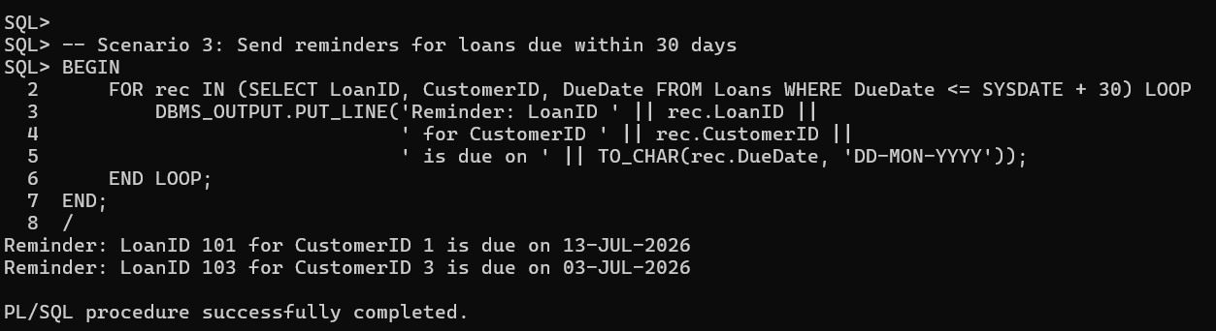
Exercise 3: Stored Procedures
SCENARIO 1:
CREATE TABLE SavingsAccounts (
AccountID NUMBER PRIMARY KEY,
Balance NUMBER(10,2)
);
INSERT INTO SavingsAccounts VALUES (1, 1000);
INSERT INTO SavingsAccounts VALUES (2, 2000);
INSERT INTO SavingsAccounts VALUES (3, 5000);
COMMIT;
CREATE OR REPLACE PROCEDURE ProcessMonthlyInterest IS
BEGIN
FOR rec IN (SELECT AccountID, Balance FROM SavingsAccounts) LOOP
UPDATE SavingsAccounts
SET Balance = Balance + (Balance * 0.01)
WHERE AccountID = rec.AccountID;

DBMS_OUTPUT.PUT_LINE('Interest applied to AccountID: ' || rec.AccountID);
END LOOP;
COMMIT;
END;
/
EXEC ProcessMonthlyInterest;
OUTPUT:
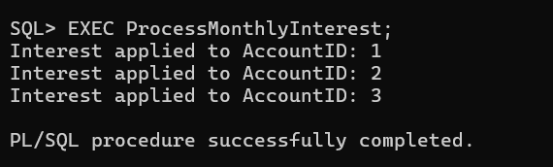

SCENARIO 2:
CREATE TABLE Employees (
EmployeeID NUMBER PRIMARY KEY,
Name VARCHAR2(50),
DepartmentID NUMBER,
Salary NUMBER(10,2)
);
INSERT INTO Employees VALUES (1, 'Anita', 10, 50000);
INSERT INTO Employees VALUES (2, 'Raj', 10, 60000);
INSERT INTO Employees VALUES (3, 'Kumar', 20, 45000);
COMMIT;
CREATE OR REPLACE PROCEDURE UpdateEmployeeBonus (
p_department_id IN NUMBER,
p_bonus_percent IN NUMBER
) IS
BEGIN
FOR rec IN (SELECT EmployeeID, Salary FROM Employees WHERE DepartmentID = p_department_id) LOOP
UPDATE Employees
SET Salary = Salary + (Salary * p_bonus_percent / 100)
WHERE EmployeeID = rec.EmployeeID;

DBMS_OUTPUT.PUT_LINE('Bonus applied to EmployeeID: ' || rec.EmployeeID);
END LOOP;
COMMIT;
END;
/
EXEC UpdateEmployeeBonus(10, 5);
OUTPUT:
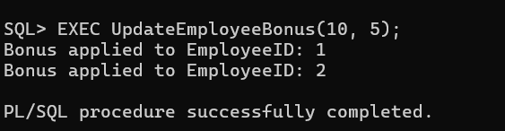
SCENARIO 3:
CREATE TABLE Accounts (
AccountID NUMBER PRIMARY KEY,
CustomerName VARCHAR2(50),
Balance NUMBER(10,2)
);
INSERT INTO Accounts VALUES (101, 'Ravi', 10000);
INSERT INTO Accounts VALUES (102, 'Meena', 8000);
INSERT INTO Accounts VALUES (103, 'Arun', 15000);
COMMIT;
CREATE OR REPLACE PROCEDURE TransferFunds (
p_source_account IN NUMBER,
p_target_account IN NUMBER,
p_amount IN NUMBER
) IS
v_balance NUMBER;
BEGIN
-- Check source balance
SELECT Balance INTO v_balance
FROM Accounts
WHERE AccountID = p_source_account;

IF v_balance < p_amount THEN
DBMS_OUTPUT.PUT_LINE('Insufficient funds in AccountID: ' || p_source_account);
ELSE
-- Deduct from source
UPDATE Accounts
SET Balance = Balance - p_amount
WHERE AccountID = p_source_account;

-- Add to target
UPDATE Accounts
SET Balance = Balance + p_amount
WHERE AccountID = p_target_account;

DBMS_OUTPUT.PUT_LINE('Transferred ' || p_amount ||
' from AccountID ' || p_source_account ||
' to AccountID ' || p_target_account);
COMMIT;
END IF;
END;
/
EXEC TransferFunds(101, 102, 2000);

OUTPUT:
